**Data-driven decision making - Manufacturing Sector**

GOKULNATH K & E24755

**Overview**

Data-driven decision-making in the manufacturing sector enables data analysts to optimize processes by leveraging real-time insights from production data. It helps improve efficiency through predictive analytics, such as forecasting equipment maintenance needs and reducing downtime. By analyzing quality metrics, it identifies defects and enhances product consistency. Additionally, it supports cost reduction by streamlining supply chain and inventory management, ensuring better resource allocation.

**Objective**

1. **Optimize Production Efficiency:** Use data insights to streamline workflows and minimize bottlenecks.
2. **Improve Product Quality:** Analyze defect trends and implement quality control measures.
3. **Enhance Predictive Maintenance:** Forecast equipment failures to reduce downtime and repair costs.
4. **Optimize Inventory and Supply Chain:** Use data to manage inventory levels, reduce waste, and improve supply chain coordination.
5. **Cost Reduction:** Identify and eliminate inefficiencies, driving down operational costs.

**Assigned Task(s)**

* Data-driven decision making - Manufacturing Sector.

**Task Details**

* **Task 35 :** Data-driven decision-making in the manufacturing sector empowers data analysts to optimize processes, reduce costs, and improve quality by leveraging real-time data and predictive analytics. It enhances efficiency through insights on production, maintenance, and supply chain management.
* **Status:** Completed.
* **Details:**

1. Analyzed datasets for production, maintenance, quality control, and inventory.
2. Data Merging: Combined all datasets based on the 'Date' column using outer joins.
3. Missing Data Handling: Filled missing values with defaults for categorical and numerical columns.
4. Calculated Fields: Added efficiency and total defects columns.
5. Visualizations:

* Line plots for efficiency, defects, and inventory levels.
* Box plots for cycle time and lead time.
* Bar plot for maintenance costs.
* Violin plot for rework costs.
* Scatter plots for units vs. defects, sensor data, inventory costs, and downtime.
* Correlation heatmap of numerical features**.**

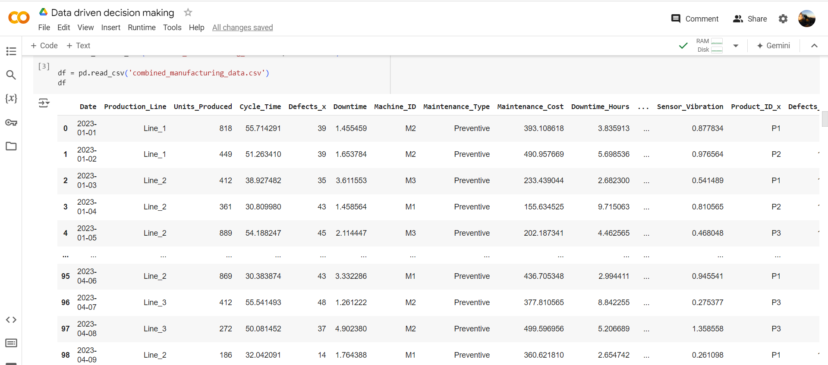

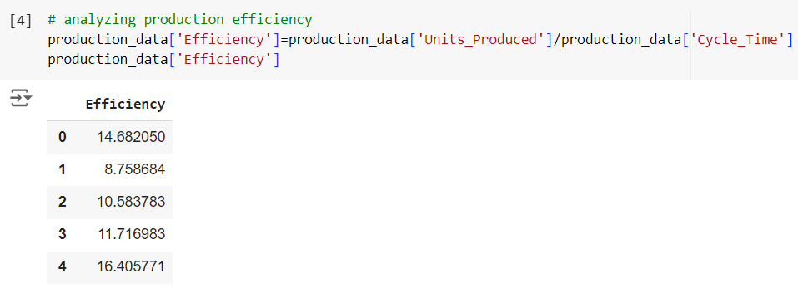

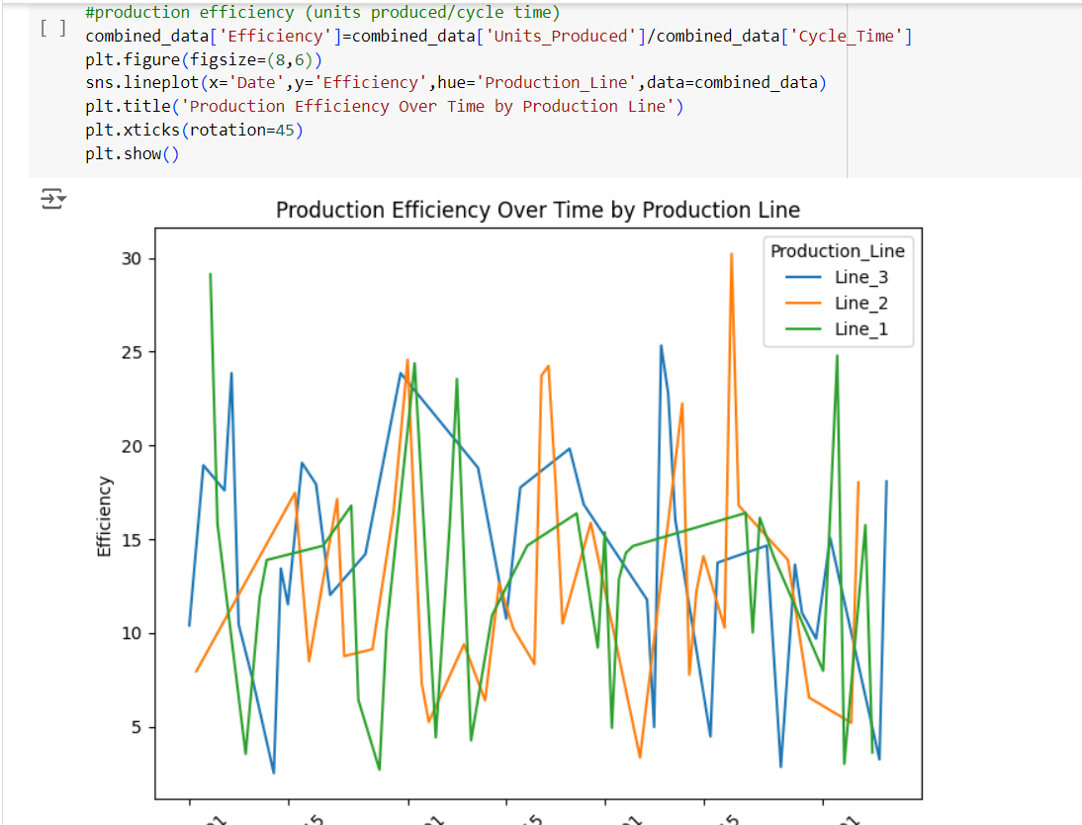

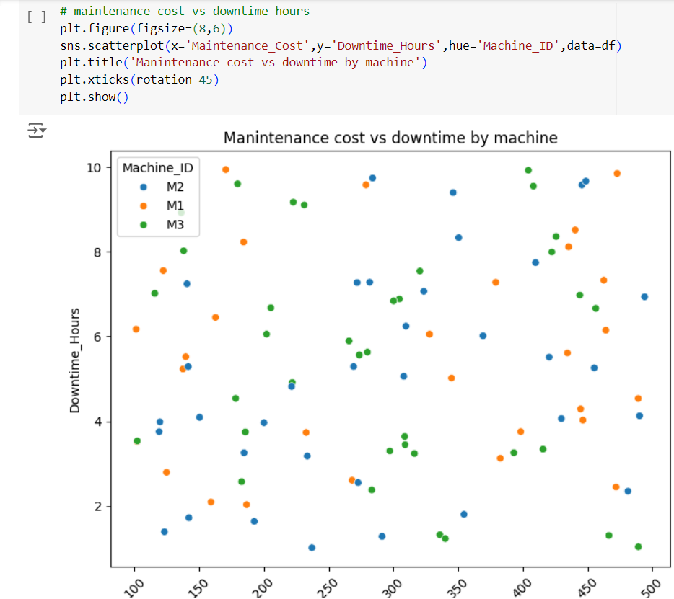

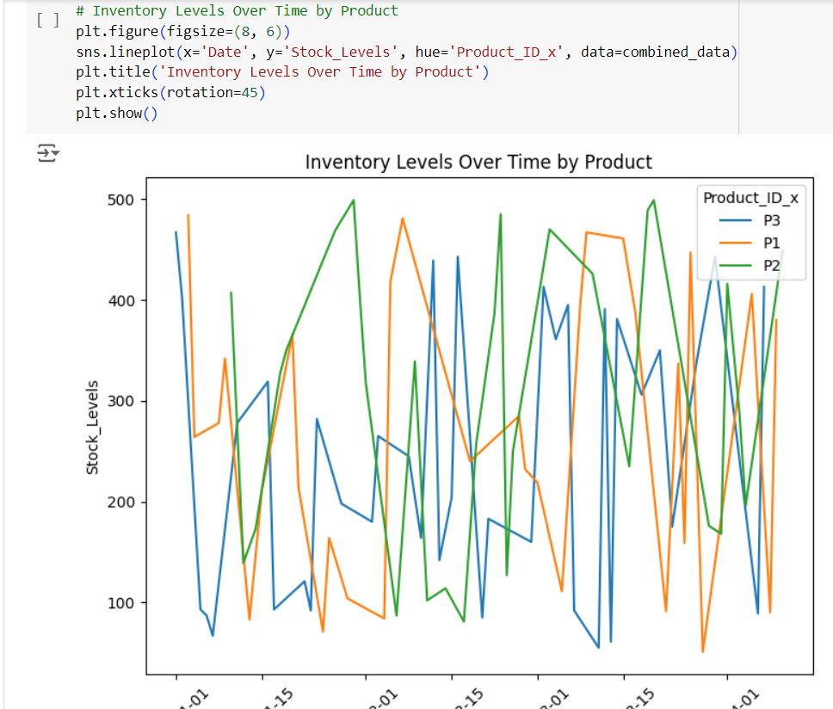

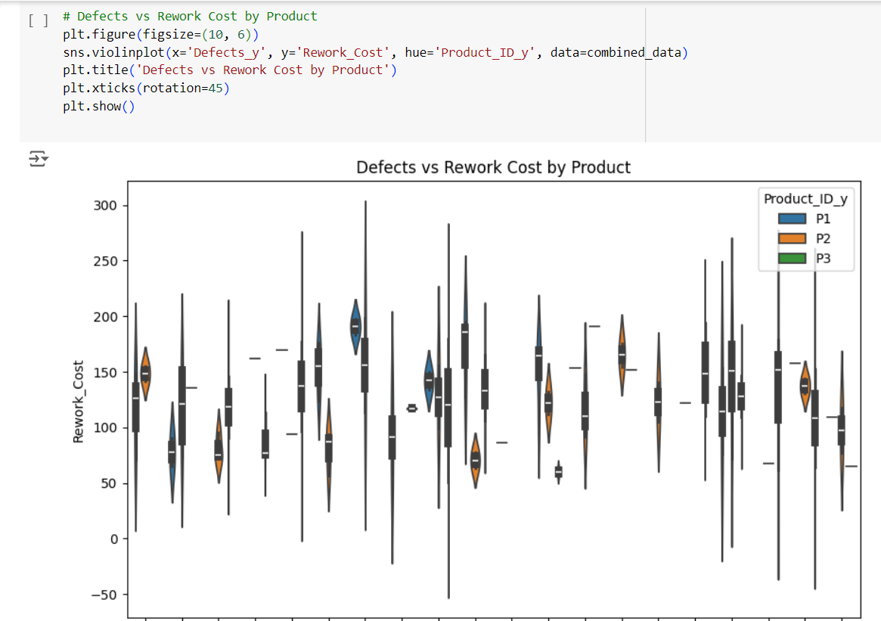

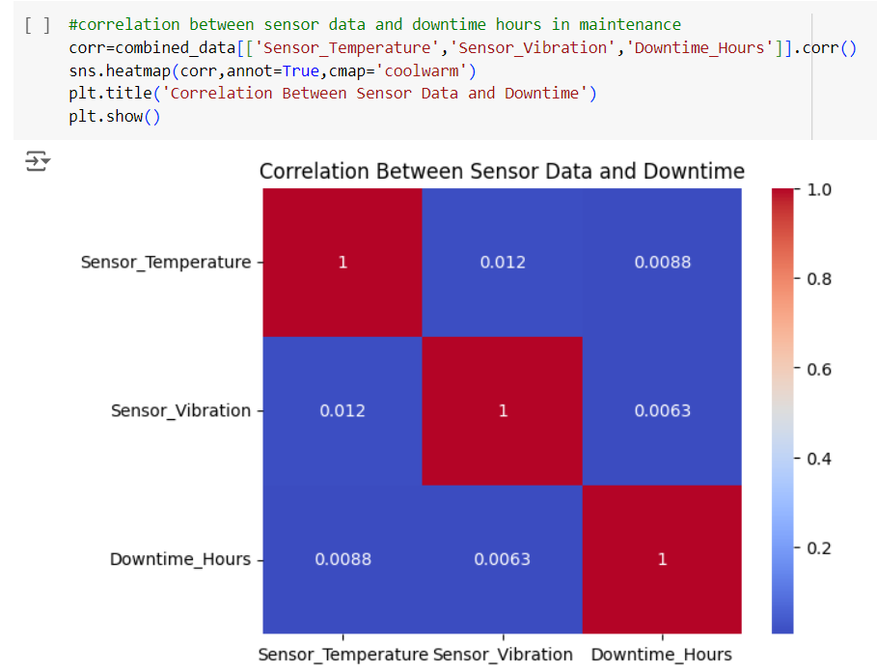

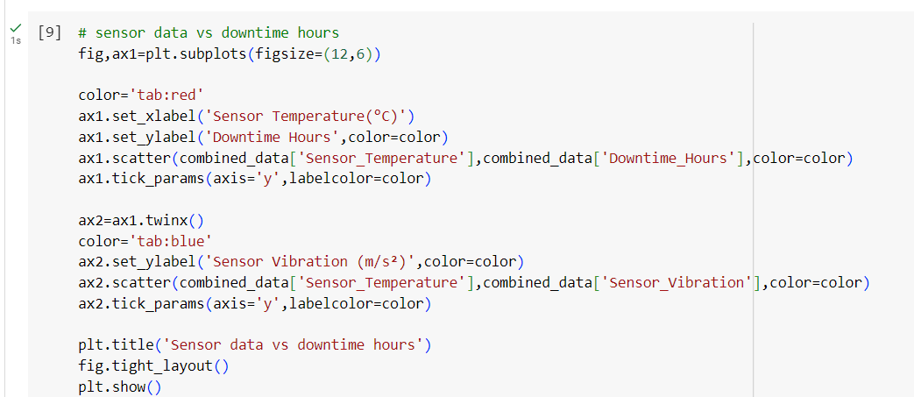

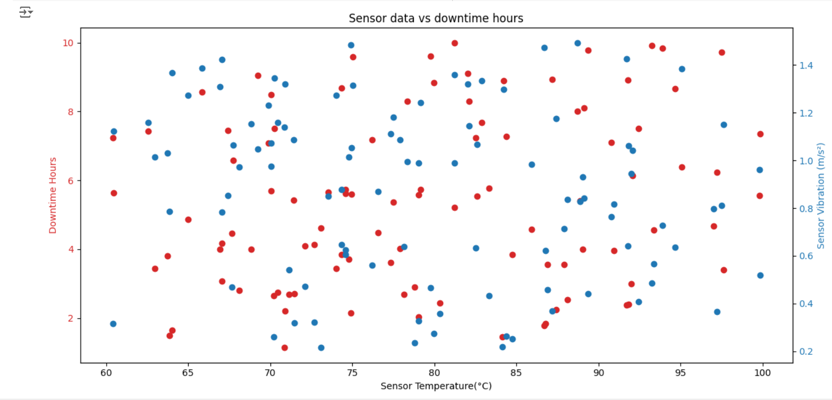

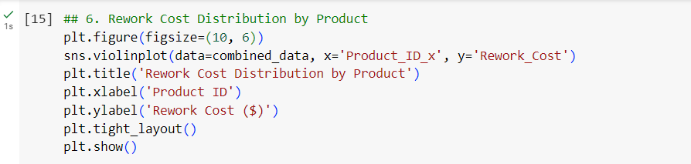

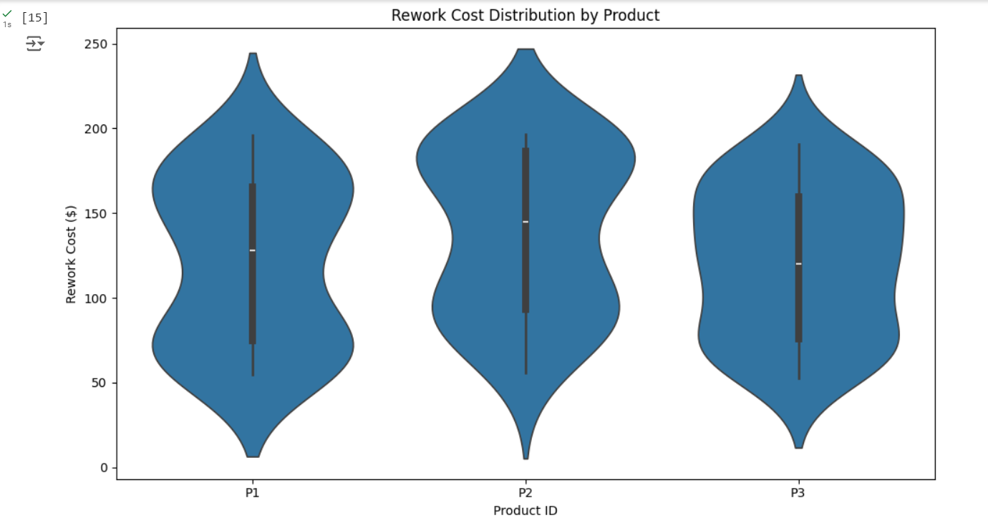

**Progress**

* **Accomplishments:** This topic simulates and integrates production, maintenance, quality, and inventory data, adding efficiency and defect metrics. It cleans and prepares the data, handling missing values and generating insightful visualizations for data-driven decision-making. The results highlight key areas such as production efficiency, defect trends, maintenance costs, and inventory performance.
* **Metrics:**

1. Production Efficiency: Calculated as Units Produced / Cycle Time.
2. Total Defects: Sum of Production and Quality Defects.
3. Maintenance Cost: Total cost associated with preventive and corrective maintenance.
4. Cycle Time: Time taken per production cycle across different lines.
5. Downtime Hours: Downtime related to both production and maintenance.
6. Sensor Data: Temperature and vibration values affecting maintenance downtime.
7. Inventory Levels: Stock levels and associated costs over time.
8. Rework Cost: Cost associated with defects in product quality.

**Challenges and Solutions**

* **Challenges Faced:**

1. Merging multiple datasets (production, maintenance, quality, inventory) can result in missing or inconsistent data.
2. Outer joins during data merging introduce NaN values that must be addressed.
3. Analyzing relationships between variables (e.g., sensor data and downtime) to find actionable insights.

* **Solutions Implemented:**

1. Use techniques to fill missing values and maintain dataset integrity.
2. Create new calculated fields like efficiency and total defects to drive insights.
3. Use heatmaps and scatter plots to identify key relationships between variables.

**Next Steps**

* **Upcoming Tasks:** Focus on analyzing data trends, improving collaboration, and implementing efficient processes to enhance productivity and decision-making in the manufacturing sector.
* **Goals:** Set clear objectives, prioritize data-driven strategies, and continuously monitor progress to achieve goals effectively in the manufacturing sector.

**Conclusion**

* **Summary:** Data-driven decision-making in the manufacturing sector enhances operational efficiency by leveraging analytics to identify trends and insights. By integrating various datasets, organizations can optimize production processes, reduce costs, and improve quality. Implementing robust metrics and visualizations allows for real-time monitoring and informed strategic planning. Ultimately, this approach fosters a culture of continuous improvement and innovation, driving sustainable growth in the industry.
* **Acknowledgements:** Thank you all for your attention and engagement, I appreciate your interest in the Data driven decision making in Manufacturing sector.